Conceptual view

The CAFCR is a method which is used to transform customer objective and key drivers in an actual system design. This method consists of five different views that include: customer view, application view, functional view, conceptual view and realization view. The customer view deals with the desires of the customer in terms of key drivers. The application view describes the needs of the customer in terms of how the customer would like to realize his goals. These two views provide the justification for the design of the system in the other three phases, or in other words, **why** the system should have certain functions. The functional view describes the system from an external perspective and shows **what** the system should do .

The last two phases describe **how** this functionality is realized. . The CAFCR method is key to transform the customer’s objectives into a possible solution which ensures a good system design which complies with the customer needs.

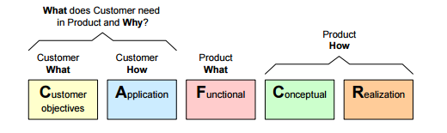

# Customer view

The customer view from the CAFCR framework is used to capture the key drivers of different stakeholders. The combined customer objectives are listed in in Fig. \ref{CA} and are ranked as performance (top-to-bottom). These can be divided in: safety, comfort, maintainability and user friendly. Safety is a common objective among the stakeholders, Comfort and User friendliness ensure a system which will be pleasurable to use on top of the safety requirements. Finally, the maintainability originates from the desire to improve the ALC in the future, as this is a project that aims to deliver a prototype.

# Application view

The customers objectives are further clarified in the application view, which are again shown in Fig. \ref{CA}. This view also deals with the demands from other users, which are in this case the regulation/law , driver, car manufacturer and dealer. For now, the car manufacturer and dealer are assumed to be out of scope, since they do not impose strict functional requirements to the system yet. Two examples regarding the application view will be explained in the following lines. First of all, to ensure safety, the system should be robust, designed in compliance with the standards and the sensor measurements should be reliable. Secondly, driver comfort can be ensured by reducing the workload of the driver, ensure smooth operation and feedback the ALC operating status back to the driver.

